Weather-Based Prediction of Wind Turbine Energy
1. Introduction
- Project Title: Wind Turbine Energy Prediction
- Team ID : LTVIP2026TMIDS74842
- Team Members:
Team Leader : Vaddi Vijaya Bhaskara Chandra
Team member : Batchu Vinay
Team member : Koduri Nooka Raju
Team member : Syed Farooq
2. Abstract
- Renewable energy forecasting plays a critical role in modern power systems where sustainability, grid stability, and operational efficiency are primary concerns. Wind energy, being highly dependent on environmental conditions, requires accurate prediction models to reduce uncertainty in generation. This project presents a Weather-Based Wind Turbine Energy Prediction System that leverages machine learning techniques and real-time weather data to forecast wind turbine power output.
- The system utilizes historical turbine operational data for training a Random Forest Regression model and integrates real-time weather inputs using the OpenWeather API. A Flask-based web dashboard enables interactive prediction, weather monitoring, and visualization of actual versus predicted power output.
- This project demonstrates the integration of data science, backend development, API integration, and visualization into a scalable renewable energy solution.
- Features:
  - Data preprocessing and cleaning.
  - Random Forest regression model for prediction.
  - Flask-based web dashboard for user interaction.
  - Integration with OpenWeather API for real-time weather data.
  - Visualization of actual vs predicted power outputs.

1. INTRODUCTION
Wind energy is one of the fastest-growing renewable energy sources globally. However, wind power generation is highly variable and dependent on atmospheric conditions such as wind speed, temperature, pressure, and humidity.
Accurate forecasting of wind turbine energy output is essential for:
- Grid stability management
- Load balancing
- Energy trading decisions
- Operational planning
- Preventive maintenance
This project proposes a machine learning-based predictive model combined with live weather integration to provide reliable energy forecasting.

2. PROBLEM STATEMENT
Wind turbines operate under fluctuating environmental conditions, causing unpredictable power generation. Traditional linear estimation models fail to capture the nonlinear relationships between meteorological variables and turbine output.
The key challenges include:
- Variability in wind speed
- Sudden weather changes
- Data noise and outliers
- Limited dataset size
- Need for real-time integration
The objective is to design a robust ML-based system that predicts energy output accurately using both historical and real-time weather data.
3. SYSTEM ARCHITECTURE
The Weather-Based Wind Turbine Energy Prediction System follows a modular, three-tier client-server architecture consisting of the Frontend Layer, Backend Layer, and Data Layer. This separation ensures scalability, maintainability, and clear responsibility distribution between user interaction, business logic, and data processing.
The architecture is designed to support real-time weather integration, machine learning inference, and interactive visualization through a web-based dashboard.

1. FRONTEND ARCHITECTURE
The frontend layer is responsible for user interaction, data input, and visualization of results. It is implemented using Flask templates with HTML, CSS, and JavaScript, ensuring seamless integration with the backend.
1.1 User Interface Design
The user interface consists of:
- Introductory landing page
- Interactive dashboard
- Weather information display panel
- Power prediction module
- Graphical visualization section
The design principles followed include:
- Minimalist layout for clarity
- Responsive design for cross-device compatibility
- Structured data presentation
- Intuitive navigation
1.2 Technologies Used
- HTML5: Defines the structural layout of the web pages.
- CSS3: Provides styling, responsiveness, and UI enhancements.
- JavaScript: Enables dynamic content updates and asynchronous API calls.
- Flask Template Engine (Jinja2): Dynamically renders backend data into HTML templates.
1.3 Dashboard Functionality
The dashboard performs the following operations:
- Accepts user input such as wind speed and theoretical power.
- Displays real-time weather parameters fetched from API.
- Sends prediction requests to backend via POST method.
- Displays prediction results without page reload (AJAX-based interaction).
- Renders visualization graphs using Matplotlib.
The frontend communicates with the backend through RESTful endpoints, ensuring loose coupling and modularity.

2. BACKEND ARCHITECTURE
The backend is built using Python Flask, which acts as the application server. It manages data processing, machine learning inference, API communication, and response generation.
2.1 Core Responsibilities
The backend performs the following functions:
- Loading the trained machine learning model.
- Receiving HTTP requests from frontend.
- Fetching real-time weather data from OpenWeather API.
- Performing preprocessing on input data.
- Generating predictions using Random Forest model.
- Returning structured JSON responses.
2.2 Flask Application Structure
The backend contains:
- app.py → Main Flask application
- model_training.py → Script for model development
- power_prediction.sav → Serialized trained model
- data/ folder → Contains dataset
Key Flask routes:
- / → Home page
- /dashboard → Main dashboard
- /predict → Prediction endpoint (POST)
- /weather → Weather API endpoint (GET)
2.3 Machine Learning Inference Pipeline
The ML inference workflow:
- Input validation
- Feature formatting
- Model loading using Joblib
- Prediction generation
- Result formatting
- JSON response return
The model is loaded once at server startup to reduce latency during prediction calls.
2.4 Weather API Integration
The system integrates with OpenWeather API to fetch:
- Wind speed
- Temperature
- Pressure
- Humidity
The backend:
- Sends HTTP request with city parameter
- Receives JSON response
- Extracts required weather features
- Handles errors (invalid city, network issues)
- Passes wind speed into ML model
API keys are stored in environment variables for security.
2.5 Error Handling and Validation
Robust validation mechanisms are implemented:
- Numeric input validation
- Empty field checks
- API response validation
- Exception handling with try-except blocks
This ensures the system remains stable even during invalid inputs or external API failures.

3. DATABASE AND DATA MANAGEMENT ARCHITECTURE
Currently, the project uses a local CSV-based dataset (T1.csv) for training and evaluation.
3.1 Dataset Storage
The dataset includes:
- Wind Speed
- Theoretical Power Curve
- Active Power Output
- Meteorological parameters
CSV format was selected due to:
- Simplicity
- Ease of manipulation using Pandas
- Lightweight structure
- Suitable for academic prototype
3.2 Model Serialization
After training, the Random Forest model is serialized using Joblib and stored as:
power_prediction.sav
Advantages of Joblib:
- Efficient storage of large NumPy arrays
- Faster model loading
- Reduced startup time
- Reusable model deployment
During runtime, the backend loads this .sav file to perform inference without retraining.
3.3 Future Database Integration
For production-level deployment, the following cloud database solutions are proposed:
MongoDB Atlas
- NoSQL document-based storage
- Flexible schema
- Scalable cluster architecture
- Suitable for storing prediction logs and user data
AWS RDS
- Relational database service
- High availability
- Automated backups
- Secure cloud integration
Future database integration will enable:
- Storage of prediction history
- User authentication records
- Performance logs
- Real-time data streaming

4. DATA FLOW ARCHITECTURE
The Data Flow Architecture describes how information moves across different components of the Weather-Based Wind Turbine Energy Prediction System. It illustrates the interaction between the user interface, backend application server, external APIs, and the machine learning model to generate real-time predictions.
The system follows a structured, sequential data pipeline ensuring low latency, data integrity, and consistent prediction output.

4.1. User Input Layer (Presentation Layer)
The data flow begins at the frontend dashboard where the user interacts with the system.
Input Parameters:
- Wind Speed (m/s)
- Theoretical Power Curve value
These inputs are entered into designated form fields in the dashboard interface.
Frontend Processing:
- Input fields perform basic client-side validation (e.g., numeric validation, non-empty fields).
- JavaScript captures the form data.
- Data is formatted into JSON structure.
At this stage, the frontend ensures that only valid and properly formatted data is transmitted to the backend server.

4.2. HTTP Request Transmission
After validation, the frontend sends a POST request to the backend endpoint:
/predict
Request Structure:
- Method: POST
- Content-Type: application/json
- Payload:
{
"WindSpeed": value,
"TheoreticalPower": value
}
This request is transmitted via HTTP protocol to the Flask server.

4.3. Backend Input Validation and Preprocessing
Upon receiving the request, the Flask backend performs:
4.3.1 Server-Side Validation
- Checks for missing fields
- Ensures numeric data type
- Validates range of wind speed
- Handles malformed JSON errors
4.3.2 Data Formatting
- Converts input values into numerical arrays
- Aligns feature order according to model training structure
- Applies necessary preprocessing (if scaling or transformation was used during training)
This ensures compatibility with the trained Random Forest model.

4.4. Real-Time Weather Data Retrieval (Conditional Step)
If the system is configured to incorporate live weather parameters:
- Backend sends a GET request to the OpenWeather API.
- API response returns JSON containing:
  - Wind speed
  - Temperature
  - Pressure
  - Humidity
Data Extraction:
- Required parameters are extracted from API response.
- Wind speed from API may override manual input (if configured).
- Data is cleaned and formatted.
Error Handling:
- Invalid city names
- API timeout
- Network failure
- Rate limiting
Fallback mechanisms ensure the system continues functioning even if API retrieval fails.

4.5. Machine Learning Prediction Pipeline
After preprocessing, the backend passes the structured feature vector to the trained model.
Model Workflow:
- Load serialized model (power_prediction.sav) using Joblib.
- Input feature array is fed into predict() method.
- Random Forest ensemble processes input through multiple decision trees.
- Each tree produces an output.
- Final prediction is calculated as the average of all trees.
Output:
- Predicted Active Power Output (in kW)
The prediction is generated within milliseconds, ensuring near real-time response.

4.6. Backend Response Generation
After prediction:
- The result is converted into JSON format.
- Response object includes:
  - Predicted Power
  - Optional weather data
  - Status message
Example JSON Response:
{
"PredictedPower": 1234.56,
"WindSpeed": 8.2,
"Temperature": 29,
"Status": "Success"
}
This structured response ensures consistent communication between backend and frontend.

4.7. Frontend Rendering and Visualization
Once the JSON response is received:
- JavaScript parses the response.
- Prediction value is dynamically inserted into the dashboard.
- Graphs are updated without page reload.
- Scatter plots and line charts reflect updated values.
Visualization Components:
- Actual vs Predicted Power Scatter Plot
- Wind Speed vs Power Output Line Graph
- Real-time weather display panel
The use of asynchronous requests (AJAX) ensures seamless user experience without refreshing the page.

4.8. Complete End-to-End Data Flow Summary
The complete data flow sequence:
- User enters wind parameters.
- Frontend validates and sends POST request.
- Backend receives and validates input.
- Optional real-time weather data is fetched.
- Input features are structured for model compatibility.
- Random Forest model generates prediction.
- Backend sends JSON response.
- Frontend displays prediction and updates visualizations.
This structured pipeline ensures:
- Minimal latency
- High reliability
- Secure API communication
- Modular scalability
- Real-time responsiveness

4,9. Data Flow Efficiency and Optimization
To maintain smooth performance:
- Model is loaded once at server startup.
- API calls are optimized.
- Lightweight JSON responses are used.
- Client-side rendering reduces backend load.
- Error handling prevents application crashes.
These optimizations guarantee real-time interaction between system components.
.

5.ARCHITECTURAL ADVANTAGES
The selected architecture of the Weather-Based Wind Turbine Energy Prediction System provides several strategic and technical benefits. By adopting a layered client-server model combined with modular machine learning deployment, the system achieves robustness, flexibility, and scalability. The architectural decisions were made to ensure long-term maintainability and efficient real-time performance.

5.1. Clear Separation of Concerns
One of the most significant advantages of the system architecture is the strict separation between presentation, business logic, and data layers.
- Frontend Layer handles user interaction and visualization.
- Backend Layer manages processing, model inference, and API communication.
- Data Layer manages dataset storage and model serialization.
This separation ensures that:
- Changes in UI design do not affect backend logic.
- Model updates do not require frontend modification.
- Data storage enhancements can be implemented independently.
Such separation improves code maintainability, debugging efficiency, and collaborative development. Each module has a clearly defined responsibility, reducing tight coupling between components.

5.2. Modular Design
The system is designed using modular programming principles.
Each functional component operates independently:
- Weather API module
- Machine Learning prediction module
- Visualization module
- Input validation module
- Data preprocessing module
This modular structure allows:
- Easy addition of new features.
- Independent testing of components.
- Simplified maintenance and debugging.
- Faster development cycles.
For example, if a different ML algorithm (such as XGBoost or LSTM) needs to be implemented, only the prediction module requires modification without affecting the entire system.

5.3. Easy Scalability
The architecture is scalable both vertically and horizontally.
Vertical Scalability
- Increase server resources (CPU, RAM)
- Optimize ML model performance
- Improve response handling capacity
Horizontal Scalability
- Deploy multiple instances of Flask server
- Use load balancing
- Integrate cloud-based database systems
- Migrate to microservices architecture
The system can easily transition from a local development environment to cloud platforms such as:
- AWS
- Google Cloud Platform
- Microsoft Azure
Scalability ensures that the system can handle increased user traffic and real-time prediction requests without performance degradation.

5.4. Efficient Real-Time Integration
The architecture supports seamless real-time data integration through RESTful API communication.
- OpenWeather API provides live meteorological data.
- Backend processes API response instantly.
- ML model generates predictions in milliseconds.
- Frontend updates dynamically without page reload.
Asynchronous communication using AJAX ensures:
- Low latency
- Smooth user experience
- Reduced server overhead
- Immediate feedback to users
This capability makes the system practical for operational environments where near real-time forecasting is critical.

5.5. SCALABILITY AND EXTENSIBILITY
The architecture allows easy future expansion:
- Cloud hosting integration
- Microservices conversion
- Containerization with Docker
- CI/CD automation
- Real-time sensor streaming
The modular nature ensures minimal refactoring during expansion.

5.6 Setup Instructions
- Prerequisites:
  - Python 3.9+
  - Flask
  - Pandas, NumPy, Scikit-learn, Matplotlib
  - Joblib
  - OpenWeather API key
- Installation:
  - Clone the repository.
  - Install dependencies using pip install -r requirements.txt.
  - Set up environment variables (API key for OpenWeather).
  - Run the Flask server with python app.py.

FOLDER STRUCTURE
- Client (Frontend):
  - templates/ → HTML files (intro page, dashboard).
  - static/ → CSS, JS, and images.
- Server (Backend):
  - app.py → Flask application.
  - model_training.py → ML model training script.
  - power_prediction.sav → Saved Random Forest model.
  - data/ → Dataset files.
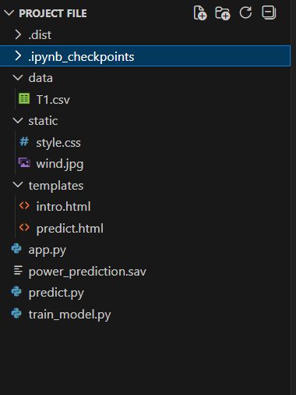

6. RUNNING THE APPICATION
- Frontend: Runs automatically via Flask templates.
- Backend: Start with python app.py.
- Access at http://127.0.0.1:5000/.
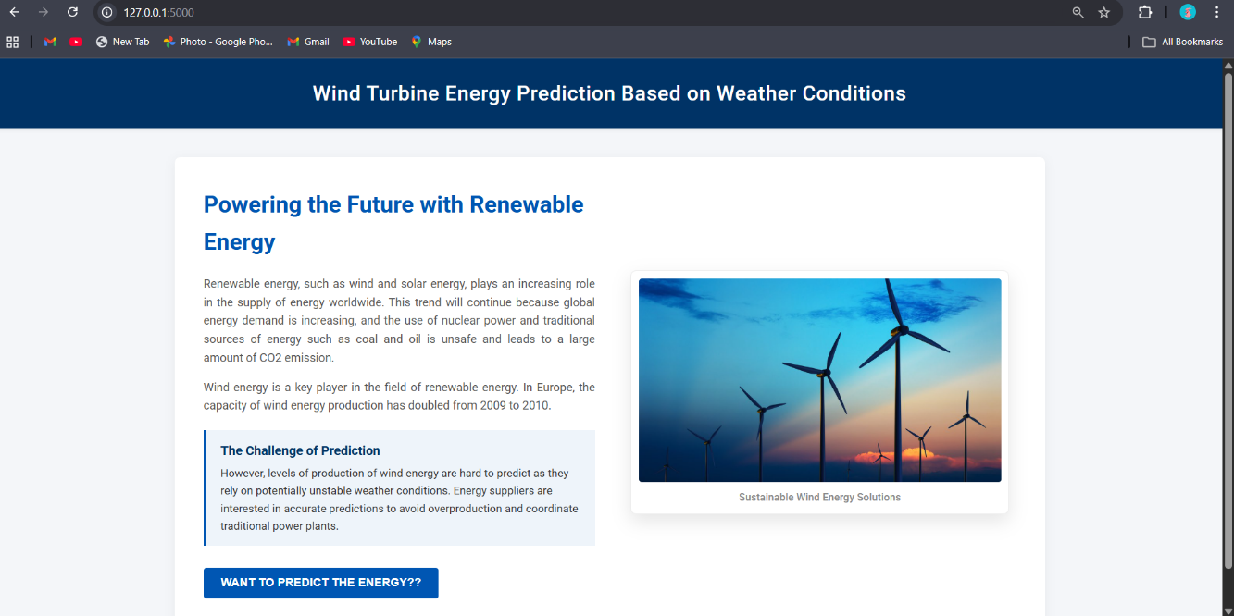

7. API DOCUMENTATION
The Weather-Based Wind Turbine Energy Prediction System exposes RESTful API endpoints that enable communication between the frontend interface and backend server. These APIs are responsible for processing prediction requests and retrieving real-time weather data.
The system follows standard HTTP conventions and uses JSON for structured data exchange.

7.1 Endpoint 1: /predict
Overview
The /predict endpoint is responsible for generating wind turbine power output predictions using the trained Random Forest regression model. It accepts input parameters from the dashboard and returns the predicted active power value.

Endpoint Details
- URL: /predict
- Method: POST
- Content-Type: application/json
- Authentication: Currently not required (future scope: JWT)

Request Parameters
The request body must contain the following parameters in JSON format:
Parameter Name | Data Type | Description
TheoreticalPower | Float | Theoretical power curve value of the turbine
WindSpeed | Float | Wind speed in meters per second (m/s)

Sample Request
POST /predict
Content-Type: application/json

{
"TheoreticalPower": 1500.25,
"WindSpeed": 8.6
}

Backend Processing Workflow
- Check for missing parameters.
- Validate numeric input type.
- Format input as feature array.
- Load serialized Random Forest model (power_prediction.sav).
- Pass input to predict() function.
- Generate predicted active power output.
- Validate JSON structure.
- Return structured JSON response.

Response Format
The API returns a JSON response containing the predicted value.
Sample Response
{
"PredictedActivePower": 1425.78,
"Status": "Success"
}

Error Handling
If invalid input is provided, the API returns an appropriate error message.
Example Error Response
{
"Error": "Invalid input. WindSpeed must be numeric.",
"Status": "Failed"
}
Possible Error Cases
- Missing parameters
- Non-numeric values
- Server-side exception
- Model loading failure
The endpoint ensures robust validation and structured error reporting.

Performance Characteristics
- Average response time: < 100 ms (local environment)
- Model inference time: Minimal due to preloaded model
- Lightweight JSON response
- No retraining during runtime

7.2 Endpoint 2: /weather
Overview
The /weather endpoint retrieves real-time weather data using the OpenWeather API. It fetches meteorological information required for power prediction and dashboard display.

Endpoint Details
- URL: /weather
- Method: GET
- Query Parameter: city
- Authentication: API key required (OpenWeather API key stored securely)

Request Parameters
Parameter Name | Data Type | Description
city | String | Name of the city for weather retrieval

Sample Request
GET /weather?city=Hyderabad

Backend Processing Workflow
- Receive city name from query parameter.
- Construct request URL for OpenWeather API.
- Append API key securely from environment variable.
- Send HTTP GET request to external API.
- Receive JSON response.
- Extract required parameters:
  - Temperature
  - Humidity
  - Pressure
  - Wind Speed
- Return structured JSON response to frontend.

Sample Response
{
"City": "Hyderabad",
"Temperature": 29.5,
"Humidity": 62,
"Pressure": 1012,
"WindSpeed": 7.8,
"Status": "Success"
}

Error Handling
The API includes structured error responses for:
- Invalid city name
- API rate limit exceeded
- Network timeout
- Invalid API key
- Service unavailable
Example Error Response
{
"Error": "City not found.",
"Status": "Failed"
}
Fallback logic ensures system stability if external API fails.

7.3 API Communication Flow
The interaction between frontend and backend APIs follows this sequence:
- User enters city name → Frontend sends GET request to /weather
- Backend fetches real-time weather → Returns JSON
- User inputs wind parameters → Frontend sends POST request to /predict
- Backend validates input → ML model generates prediction
- JSON response sent to frontend
- Dashboard updates dynamically
This structured communication ensures low latency and real-time responsiveness.

7.4 Security Considerations
Current Implementation:
- Open access endpoints
- API key stored in environment variables
Future Enhancements:
- JWT authentication
- HTTPS encryption
- Rate limiting
- Role-based access control
- API request logging

7.5 API Design Advantages
The API design offers:
- RESTful structure
- Lightweight JSON communication
- Clear separation of endpoints
- Structured error handling
- Scalability for microservices
- Easy cloud deployment

8. AUTHENTICATION
- Currently open access.
- API key required for OpenWeather API integration.
- Future scope: JWT-based authentication for secure access.

9. USER INTERFACE
- Intro page with project overview.
- Dashboard with:
  - Weather data display.
  - Prediction module.
  - Visualization graphs.
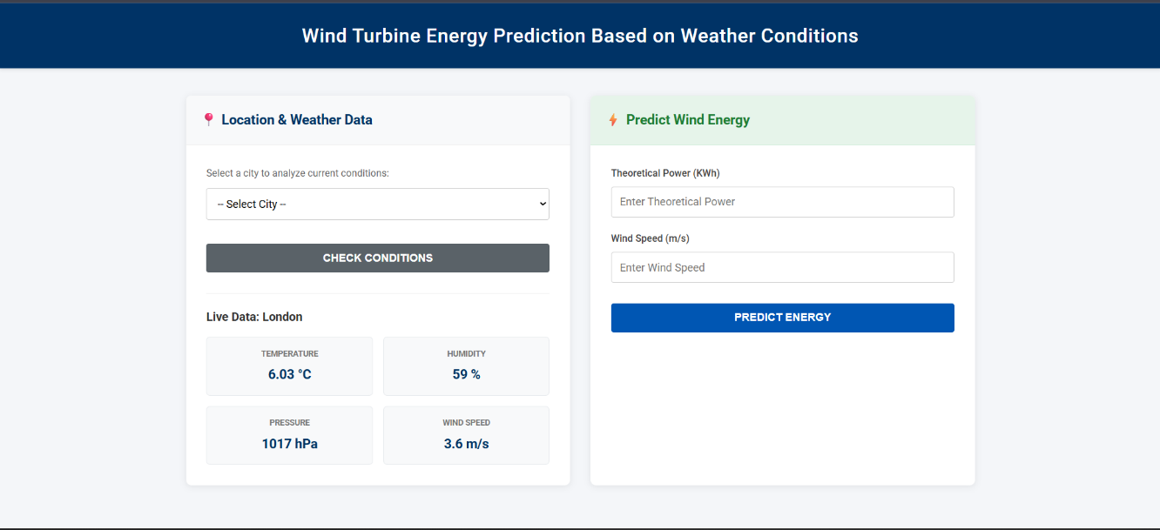

10. TESTING
- Unit testing for ML model predictions.
- API testing for weather data retrieval.
- Functional testing for input validation and dashboard navigation.
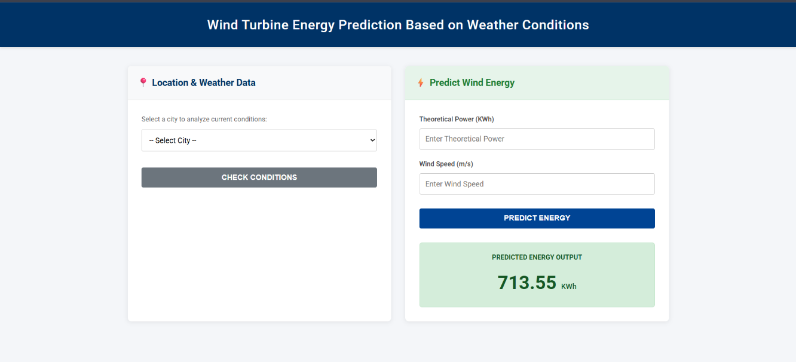
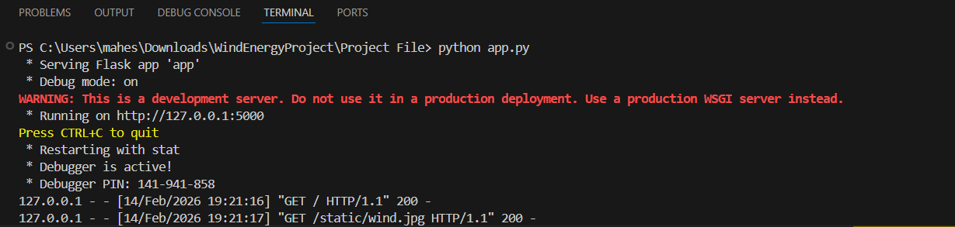

11. Screenshots or Demo
- Dashboard screenshot showing weather + prediction results.
- Line chart trends of wind speed vs power output.
- Scatter plot of actual vs predicted power.

12. KNOWN ISSUES
Despite achieving strong predictive performance and stable system integration, the Weather-Based Wind Turbine Energy Prediction System has certain limitations and known issues that must be acknowledged. These limitations primarily relate to dataset constraints, API dependency, and security architecture.

12.1 Limited Dataset Size and Generalization Constraints
The machine learning model was trained using a limited historical dataset (T1.csv). While the model demonstrates good predictive performance within the training distribution, limited data may affect:
- Model generalization to unseen weather conditions
- Performance during extreme wind scenarios
- Long-term seasonal prediction reliability
- Accuracy across different turbine models
Impact on Model Performance
- Risk of overfitting to training data
- Reduced robustness in highly variable weather patterns
- Limited ability to capture long-term temporal dependencies
Mitigation Strategy (Current)
- Proper train-test split (80:20)
- Correlation analysis
- Feature engineering
- Ensemble learning using Random Forest
However, expanding the dataset and incorporating multi-season historical data would significantly improve reliability.

12.2 External API Dependency and Error Handling
The system depends on the OpenWeather API for real-time meteorological data. This introduces several operational risks:
Potential Issues
- Invalid city name input
- API rate limit exceeded
- Network latency
- Server downtime
- Invalid or expired API key
If an invalid city name is entered, the API may return an error response, which must be handled gracefully.
Current Handling Mechanisms
- Try-except error handling
- JSON error responses
- Input validation for city field
- Fallback mechanisms for manual wind input
Despite these measures, external API dependency introduces uncertainty beyond system control.

12.3 Lack of Authentication and Access Control
Currently, the dashboard is publicly accessible without authentication.
Security Risks
- Unauthorized access
- Potential misuse of API calls
- Excessive prediction requests
- Exposure of backend endpoints
Although API keys are stored securely in environment variables, user-level authentication is not implemented.
This represents a structural limitation that must be addressed before production deployment.

12.4 Absence of Time-Series Forecasting
The current model performs regression-based prediction using static input parameters. It does not incorporate:
- Historical sequential time patterns
- Multi-step forecasting
- Seasonal trend modeling
- Temporal lag features
This limits its capability for:
- Long-term energy planning
- Hourly/daily forecast simulation
- Predictive maintenance scheduling

12.5 Single-Model Architecture
The system uses only one ML algorithm (Random Forest). While effective, it does not implement:
- Model comparison frameworks
- Ensemble stacking
- Deep learning alternatives
- Automated hyperparameter tuning pipelines
This reduces experimentation flexibility.

13. FUTURE ENHANCEMENTS
To transform this prototype into an enterprise-level renewable energy forecasting platform, several enhancements are proposed.

13.1 Cloud Deployment (AWS / GCP / Azure)
Migrating the application to cloud infrastructure will provide:
- High availability
- Load balancing
- Auto-scaling capabilities
- Secure deployment
- Remote accessibility
Possible Deployment Stack
- Backend: AWS EC2 or Azure App Service
- Database: AWS RDS / MongoDB Atlas
- Storage: AWS S3
- CI/CD: GitHub Actions or Jenkins
Cloud deployment ensures production readiness and operational scalability.

13.2 JWT-Based Authentication and Authorization
To secure dashboard access, JSON Web Token (JWT) authentication can be implemented.
Benefits:
- Secure login system
- Token-based stateless authentication
- Role-based access control
- API protection
- User session management
Possible user roles:
- Administrator
- Energy Analyst
- Viewer
This upgrade significantly enhances system security.

13.3 Dataset Expansion and Model Improvement
Improving prediction accuracy requires larger and more diverse datasets.
Enhancement Strategies:
- Collect multi-year historical turbine data
- Integrate data from multiple wind farms
- Include additional meteorological features
- Add seasonal and geographic variability
- Include turbine operational metrics
Advanced models to explore:
- XGBoost
- Gradient Boosting Machines
- LSTM (Long Short-Term Memory)
- Hybrid ensemble models
This will improve robustness and generalization.

13.4 Advanced Visualization and Analytics
Current visualizations include scatter and line plots. Future improvements may include:
- Correlation heatmaps
- Feature importance charts
- Time-series forecasting graphs
- Power output trend analysis
- Seasonal decomposition plots
- Interactive dashboards using Plotly or D3.js
Enhanced visualization improves decision-making clarity for stakeholders.

13.5 Integration with Grid Demand APIs
To extend practical usability, the system can integrate with power grid demand APIs.
Use Cases:
- Real-time supply-demand balancing
- Load prediction adjustment
- Energy trading optimization
- Grid stability monitoring
- Smart grid automation
This integration transforms the system from a prediction tool into a smart energy management solution.

13.6 Real-Time Turbine Sensor Integration
Future versions can directly integrate with IoT-based turbine sensors.
Benefits:
- Live operational monitoring
- Fault detection
- Predictive maintenance
- Automated alerts
- Edge computing capabilities
This would elevate the system to an industrial-grade renewable energy analytics platform.

13.7 Microservices Architecture Conversion
For enterprise scalability:
- Separate ML service
- Separate API gateway
- Independent weather service
- Database service layer
This ensures fault isolation and improved performance.

14. Conclusion
The Wind Turbine Energy Prediction project successfully demonstrates the application of machine learning and data-driven techniques to solve a real-world renewable energy challenge. By leveraging historical turbine data, preprocessing methods, and a Random Forest regression model, the project achieves strong predictive accuracy, enabling stakeholders to forecast energy output with confidence.
The integration of a Flask-based dashboard and OpenWeather API ensures that predictions are not only technically sound but also accessible and user-friendly. Visualizations such as scatter plots, line charts, and correlation heatmaps further enhance interpretability, making the solution practical for energy companies, wind farm operators, and grid managers.
Through structured Agile sprint planning, backlog management, and performance testing, the project was executed with clarity and measurable progress. Testing confirmed the robustness of the model, while defect analysis and bug tracking highlighted areas for improvement.
Ultimately, this project provides a scalable foundation for future enhancements, including cloud deployment, advanced authentication, expanded datasets, and integration with grid demand APIs. It stands as a strong example of combining data science, software engineering, and agile methodology to deliver a solution that addresses both technical and customer-centric needs in the renewable energy sector.

